MATHS FUN DAY

At Woburn Lower School our principal aim in mathematics is to develop children’s knowledge, skills and understanding in a fun, practical way, encouraging the children to apply their learning to different situations in order to maximise their learning and understanding. We aim to engage the children in their learning and to develop a positive, confident attitude towards mathematics.

As part of our mathematical strategy we held a ‘maths fun day’. Activities were set out in each classroom relating to the key learning strands of shape, measurement and capacity.

The children circulated around the classrooms, exploring and investigating the resources and activities set out for them, working together in mixed age groups.

In the Owls classroom they explored shape, working together to creatively solve problems using a variety of 2D and 3D shapes in all sizes.

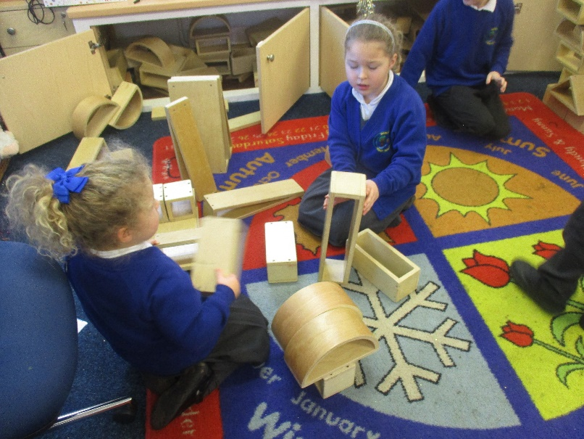

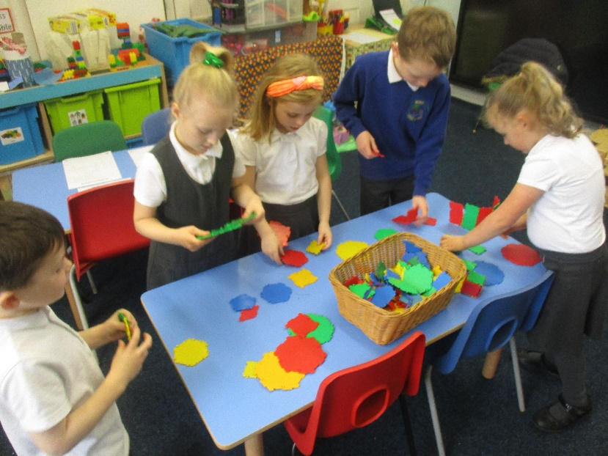

In Squirrels class they explored capacity. They made some potions, poured rice from container to container, filled the sink with different containers and filled their cups with the squeeze of a sponge!!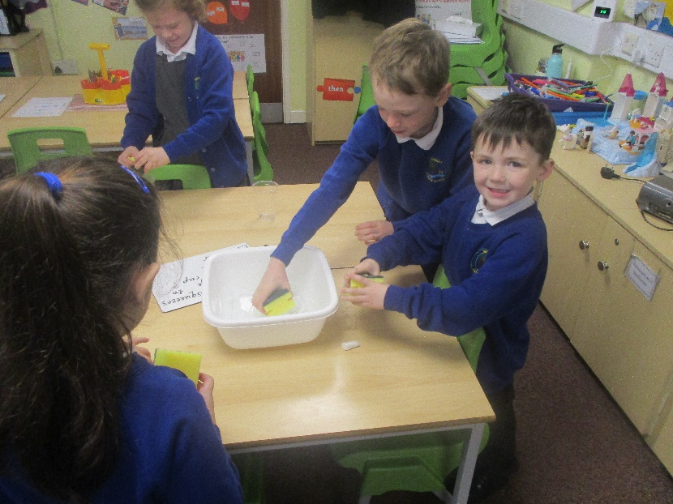

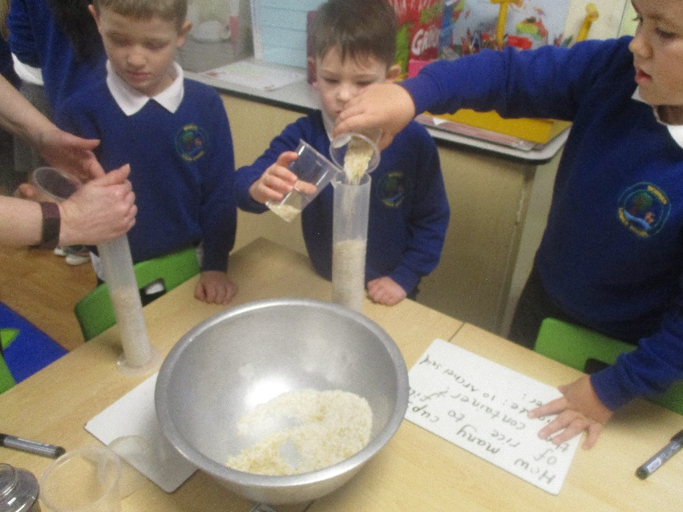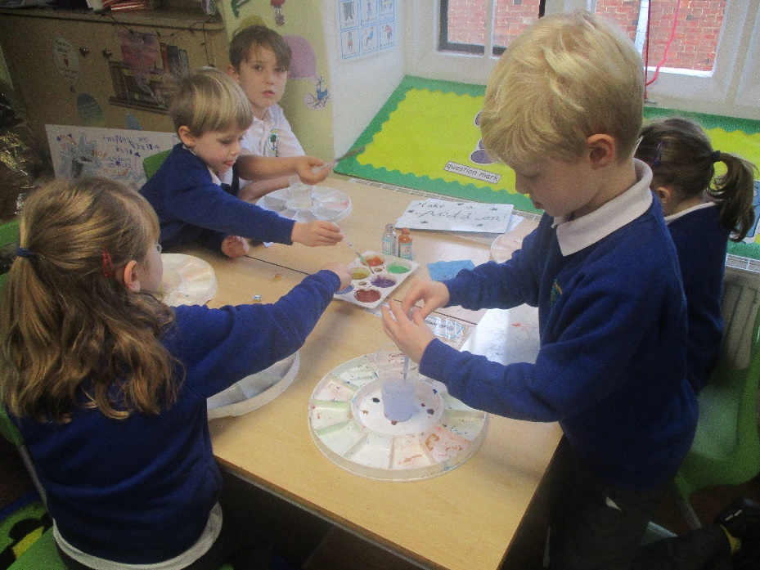

In Badgers class they were set a challenge based on estimation of time. The children enjoyed estimating how many times they could jump in 2 minutes, how may times they could take their jumper off in 2 mins and how many times they could write their name in 2 mins.

